**Sprint 1 Report - HungrySlug**

The sprint report must contain the following elements:

**Heading:** Sprint 1 Report, HungrySlug, Team HungrySlug, 04/23/24.

**Actions to stop doing:**

1. Stop waiting for someone else to be done with their task if you have been waiting a while for them to finish. Instead, try to find something else that can be done in the project.
2. Stop assuming that all the tasks will finish immediately and instead use some sort of plan or buffer to adjust if a task is stuck.

These are the activities or actions the team determined they should stop doing. This is the answer to the question, "What things should we stop doing?" The items should take the form of a brief description of what the team wants to stop doing, followed by a brief explanation. If there are no items, this section should describe why the team is completely satisfied with their current process.

Examples: The team should stop holding daily scrum meetings at 7am in the morning, because nobody can make that meeting time. The team should stop allowing daily scrum meetings to go over 15 minutes, because the meetings are less effective that way.

**Actions to start doing:**

1. Communicate when there are major issues with tasks that may affect the progress of other tasks.
2. Communicate the creative choices that may affect other team member’s tasks.
3. Scrum master could start “encouraging” the completion of tasks and modify the task if necessary.
4. Increase the amount of documentation in the form of README files or comment on what each part of your code does.
5. Create a Figma design in order to see what the future UI of the app will look like and prevent people from creating conflicting design choices.
6. Meet in person more to discuss what is the current state of the project and how things work inside of the project.

These are the activities or actions the team would like to start doing to improve their development process. This is the answer to the question, "What should we start doing?" The items should take the form of a brief description of what the team wants to start doing, followed by a brief explanation.

Examples: The team should schedule more group work sessions, since these are very effective at getting work done. The team should be more accurate at estimating work tasks, since tasks were consistently under-estimated last sprint.

**Actions to keep doing:**

This is the answer to the question, "What is working well that we should continue to do?" The items should take the form of a brief description of what the team wants to start doing, followed by a brief explanation.

1. Continue updating the team during scrum meetings.
2. Continue not pushing to main.

This is the answer to the question, "What is working well that we should continue to do?" The items should take the form of a brief description of what the team wants to start doing, followed by a brief explanation.

**Work completed/not completed:**

1. User Story 1 - Complete
2. User Story 2 - Incomplete
   1. Missing sign in page, rating, user profile pages, and friend system.

This is a list of the user stories that were completed during the previous sprint, and a list of the user stories not completed during this sprint (but which were part of this sprint, and were in the sprint plan).

**Work completion rate:**

1. ½ user stories complete
2. 9/18 Tasks complete
   1. Tasks 1-7 + Task 14 + Task 15 Complete
   2. Tasks 8-12 + Task 15-18 In Progress

Task List:

* ~~Create a barebone website that can be built upon for future features. I think using~~ **~~React~~** ~~will be a good idea. Also with a GitHub page. (60 mins)~~
* ~~Connect a~~ **~~Python~~** ~~backend or some other language to the website. (Flask, Django) (30 mins)~~
* ~~Create some form of database to store data. This could be~~ **~~Firebase~~**~~. (30 mins)~~
* ~~Be able to get the data raw from the ucsc dining hall website and store the data in classes related to dining hall and meal time. (45 mins)~~
* ~~Convert class data in~~ **~~Python~~** ~~into~~ **~~Firebase~~** ~~database storage. (30 mins)~~
* ~~Be able to fetch data from~~ **~~Firebase~~** ~~and make them back into class data. (20 mins)~~
* Attempt to create a backend task that is running at all times and updates the firebase database with new changes to the menu.
* ~~Implement a~~ **~~CSS~~** ~~framework to make things look nice (Tailwind CSS) (5 mins)~~
* Create a table to display foods to users. (20 mins)
* ~~Create a way to select a dining hall. (10 mins)~~
* Check the time of day to hide and show certain meals to users. (10 mins)
* ~~Initial navigational aspects to the website for current and future pages. Navigation bar with blank pages. (20 mins)~~
* 13. Create a means of rating a dining hall meal on the backend. (30 mins)
* 14. Create a sign in page or login page. (60 mins)
* 15. Use **MongoDB** to keep track of all users that use the website. (60 mins)
* 16. Create a user profiles page that displays current known information about the user. (30 mins)
* 17. Create a friends system and display who your friends are. (60 mins)
* 18. Improve the web scraper to be able to fetch from all types of food places on campus.

Estimated/Ideal a total of 9.5 hours initially

Estimated/Ideal 1 user story every 7 days

Estimated/Ideal 1 hour of work a day

Actual hours worked was roughly 47 hours total

Actual 1 user story completed in 14 days

Actual 3.5 hours of work a day

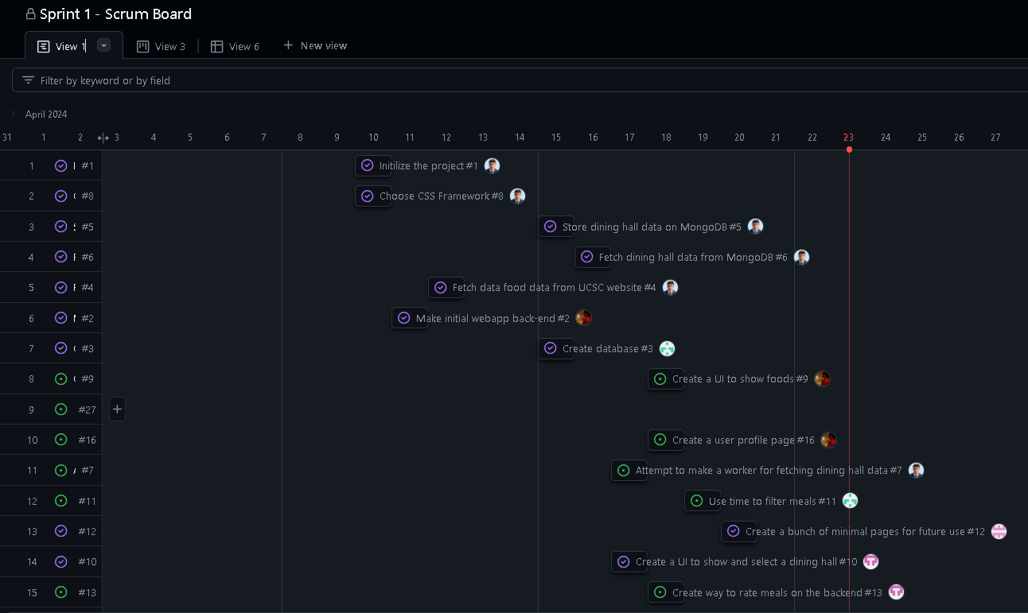

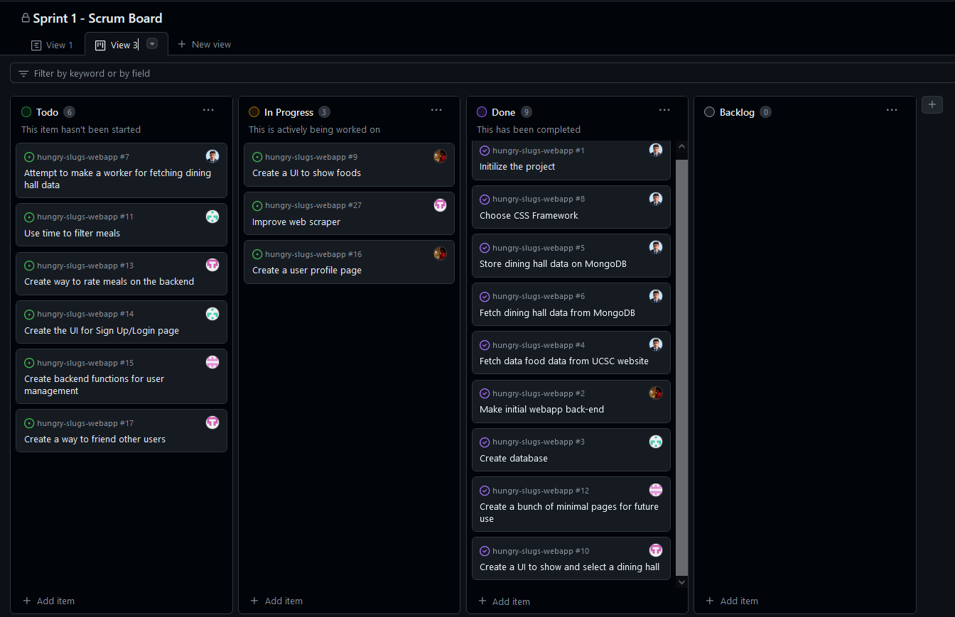

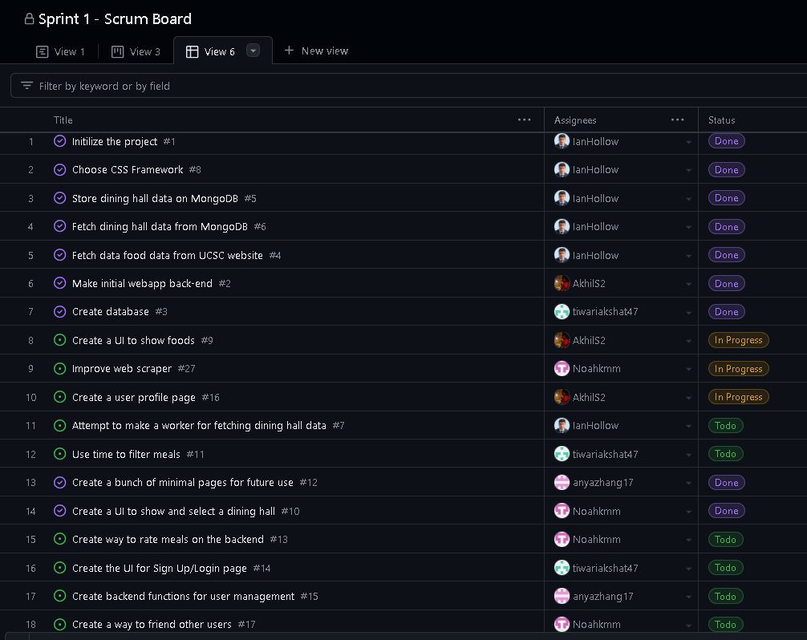

This section should report the following: total number of user stories completed during the prior sprint. Total number of estimated ideal work hours completed during the prior sprint. Total number of days during the prior sprint. For the previous sprint, the user stories/day and ideal work hours/day figures should be reported. For sprints past the first sprint, this section should also provide the average user stories/day and average ideal work hours/day figures computed across all sprints to date. The final sprint burnup chart for the previous sprint should be available for viewing in the lab and an email of this chart sent to the TA/prof.